Summer Internship – 2025

By Uptoskills

Duration :- 6 Months

Start Date :- 6/12/2025

End Date :- __________

Name :- Sarthak Dangi

Course :- B.Sc (Hons) Forensic Science

Interview Date :- 6/12/2025

Offer Letter Date :- 6/12/2025

Domain Team Leader :- Mohit Saini

Co Domain Team Leader :- Ashutosh Maurya

Task – Nmap Tool (Network Scanning & Enumeration)

Task Number :- 4

Date of Allotment :- 2 January 2025

Project Briefed :-

Network scanning and service enumeration using Nmap on a vulnerable target machine.

Objective

To explore the Nmap tool at an average level to identify live hosts, open ports, running services, service versions, and OS details in a controlled lab environment.

Tool Used

Tool Name: Nmap

Operating System: Kali Linux

Target Machine: DVWA / Metasploitable2

Network Type: Local Virtual Network

Commands Used & Procedure

1. Verifying Nmap Installation

Command: nmap --version

2. Host Discovery

Command: nmap -sn 192.168.1.0/24

3. Basic Port Scan

Command: nmap 192.168.1.10

4. TCP SYN Scan

Command: nmap -sS 192.168.1.10

5. Service Version Detection

Command: nmap -sV 192.168.1.10

6. OS Detection

Command: nmap -O 192.168.1.10

7. Aggressive Scan

Command: nmap -A 192.168.1.10

Findings

Multiple open ports such as FTP, SSH, and HTTP were identified. Services and OS details were successfully detected.

Result

The Nmap tool successfully performed network scanning and enumeration, providing useful reconnaissance data.

Ethical Consideration

This activity was conducted in a controlled lab environment for educational purposes only.

Conclusion

This task improved understanding of network scanning using Nmap, an essential tool in cybersecurity.

# Screenshots (Practical Proof)

Screenshot 1: Nmap Version Verification

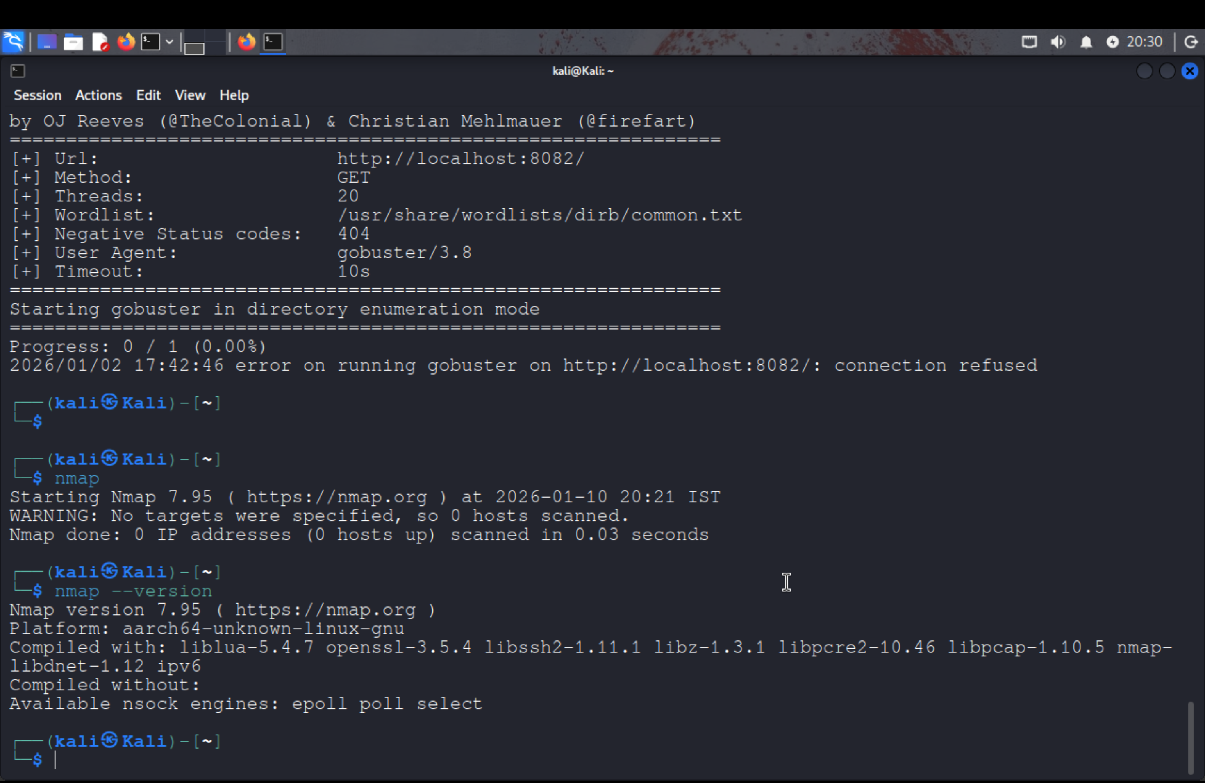

Screenshot 2: Basic Port Scan on Localhost

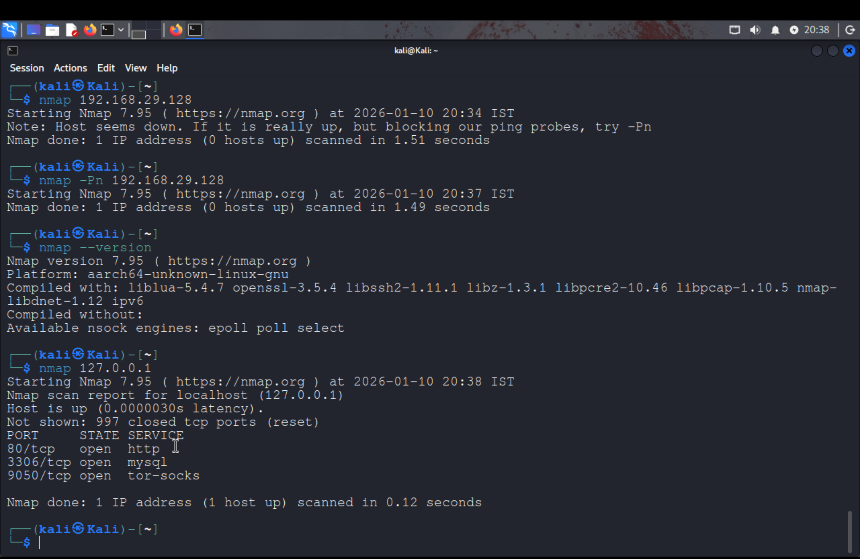

Screenshot 3: TCP SYN (Stealth) Scan

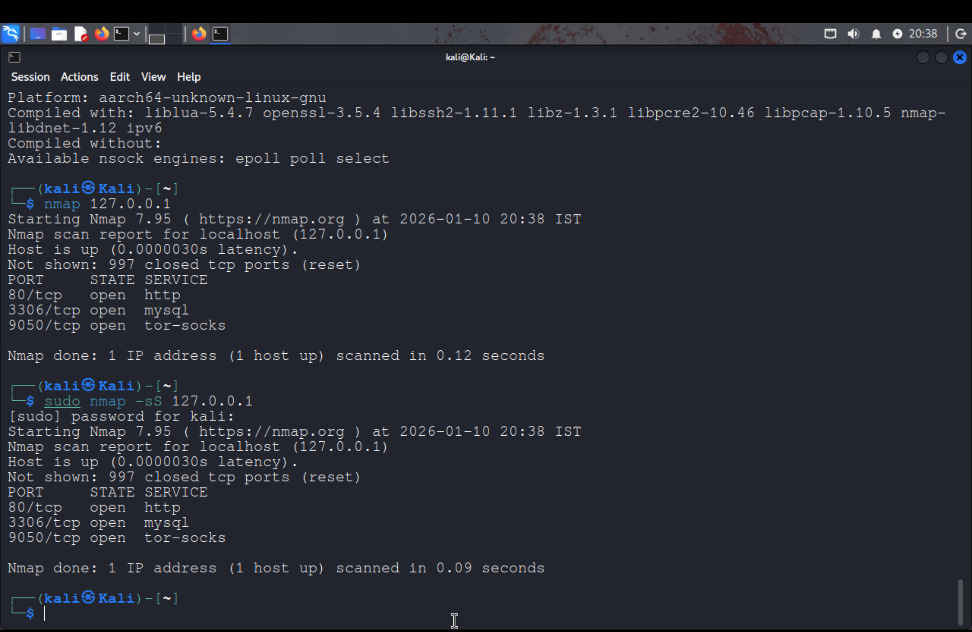

Screenshot 4: Service & Version Detection

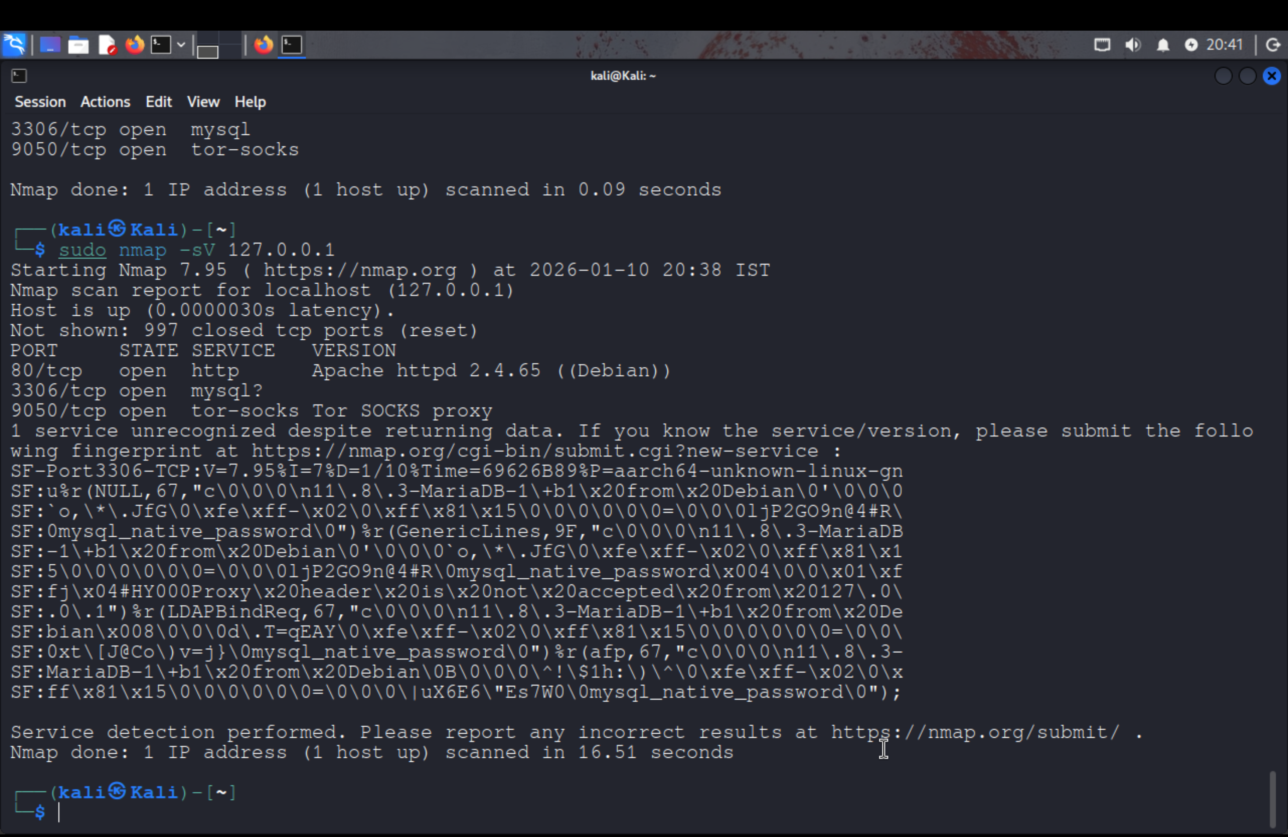

Screenshot 5: Aggressive Scan Output

